Quiz_Lecture09

Name：刘承奇 Student ID：2018533249

The BN for diagonal LDA：

Suppose there are m input variables. Let them be X1, X2, … , Xm.

After diagonalization, the m variable becomes X1’, X2’, … , Xm’.

G is the output label of the classification.

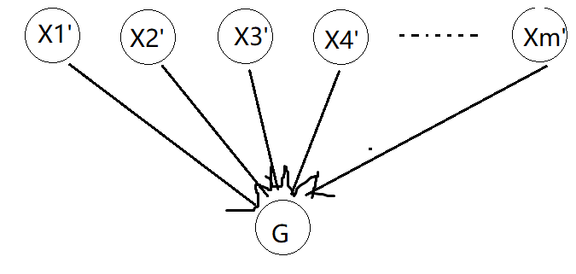

(The BN for LDA without diagonal：)

